DEACTIVATE/REACTIVATE ONE STEP UPDATE (EWC)
Quicken Windows 2008-2010


- Right click the account in the Quicken Account List

- Select Edit Account from pop-up.

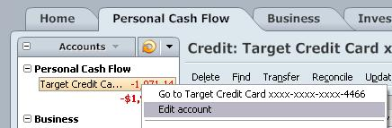

- Click the Online Services tab. In the One Step Update section, it will state the connection method the end user is using. To disable the account, click on the "Remove from One Step Update" button.

NOTE: If account is connected with Web Connect it will show an option to Remove Connection. Click on this to deactivate the account.

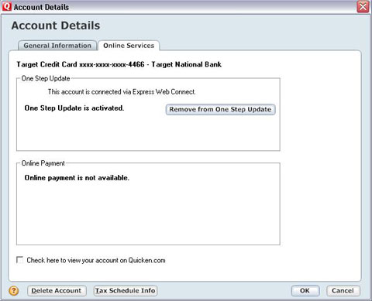

ACTIVATE WEB CONNECT ONLY

- Login onto your FI website from an external browser to initiate a download of Web Connect file into Quicken. When presented with the below screen, choose the "Use an existing Quicken account" radio button

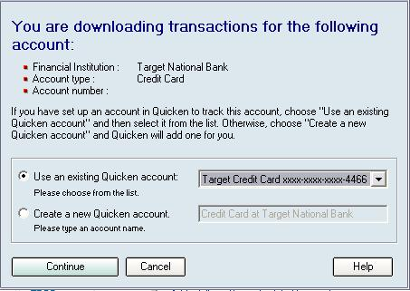

NOTE: Now the account will be connected via Web Connect. Quicken may prompt to activate One Step Update after a successful Web Connect download. Please select No do not activate and check the box to not be prompted again. Screen shot on the next page.

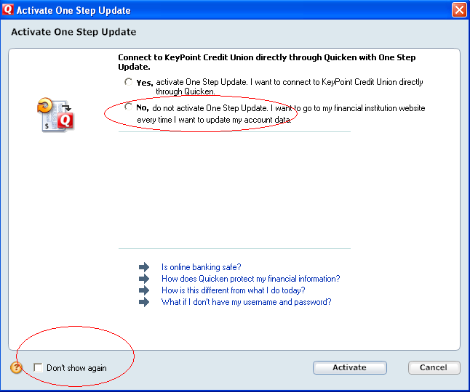

REACTIVATE ONE STEP UPDATE (EWC)

- Right click the account in the Quicken Account List

- Select Edit Account from pop-up.

- Click the "Activate One Step Update" button and follow the onscreen prompts to complete the One Step Update activation process. Now the account will be connected using Express Web Connect.

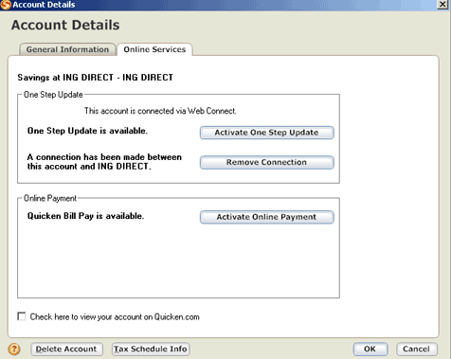


You will be prompted to provide your login credentials and a list of available accounts will be presented. Check any that you want to set up for Express Web Connect. Intuit will log in to the online banking system daily on your behalf and collect the transactions available. When you want to process them, simply click One Step Update and they will automatically download into your accounts for processing.

If you wish to cancel this process, you will need to Deactivate Express Web Connect, which will delete the login token from Intuit’s servers.

